4×4 HDMI Matrix Switch
User Manual

4Kx2K

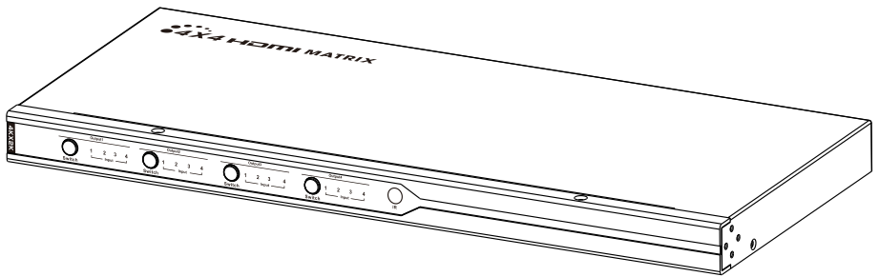

Thank you for purchasing this product. For optimum performance and
safety, please read the instructions carefully and keep the manual for
future reference.

Important safety notice
Please read below safety instructions carefully before installation
and operation:
* Please pay attention to all the warnings and hints on this device.
* Do not expose this unit to rain, moisture and liquid.
* Do not put any stuff into the device.
* Do not repaire the device or open the enclosure without professional
person guidence to avoid electronic shock.
* Make sure good ventilation openings to avoid product overheating
damage.
* Turn off power and make sure environment is safe before installation.
* Do not plug-in/out the connection cables when it is in using to avoid
cables damage.
* Use DC12V only. Make sure the specification matched if using 3rd party
DC adapters.

Introduction
This product is a 4×4 HDMI HD Matrix Switch, with 4 HDMI inputs and
4 HDMI outputs. 4 HDMI inputs accommodate the simultaneous
connection up to 4 high definition video sources, such as satellite
systems and Blu-ray players. 4 HDMI outputs send the high definition
audio/video signals to 4 HDTV displays. This Matrix Switch supports
IR remote control and button control for switching inputs and outputs.
This product is perfect for security system, digital monitoring system,
school education system, exhibition center, multimedia conference,
command system etc.
Features
1. Support 4 HDMI signal input and 4 HDMI signal output.
2. Support up to ultra HD resolution 4K×2K@30Hz.
3. Transmission data rate up to 10.2Gbps.
4. Support IR remote control.
5. Support RS232 control.
6. Support button control for switching inputs/outputs.
7. Pure hardware design, plug and play.
8. Support3D.
9. Support YUV4:2:2.
Package contents
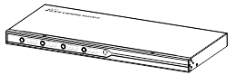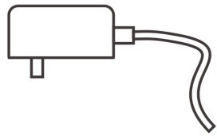
Matrix Switch unit ×1pcs DC12V2A power adapter ×1pcs
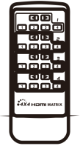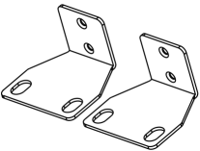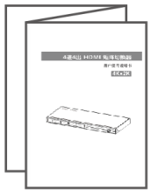
Remote Controller ×1pcs Wall-mount kit x2pcs User manual ×1pcs

Installation Requirement
1. HDMI source device (DVD, PS3, Set top box, PC etc)
2. HDMI display device like SDTV, HDTV, and projector with
HDMI port.
Panel description
Front Panel
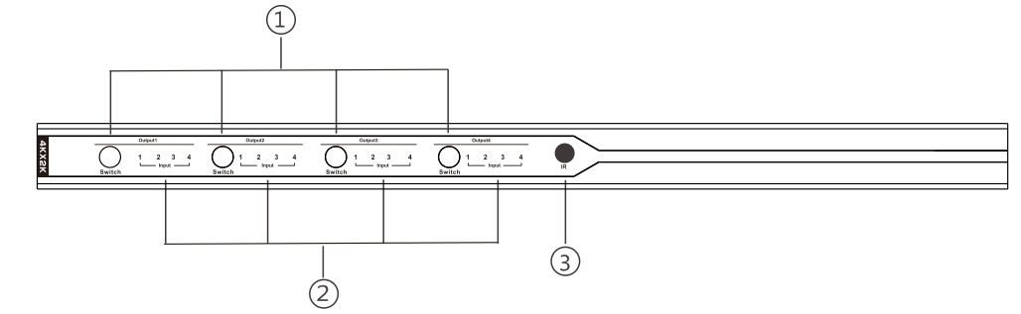
① Switch:To choose input channel ② Input Select indicator
③ IR Receiving window

Back Panel
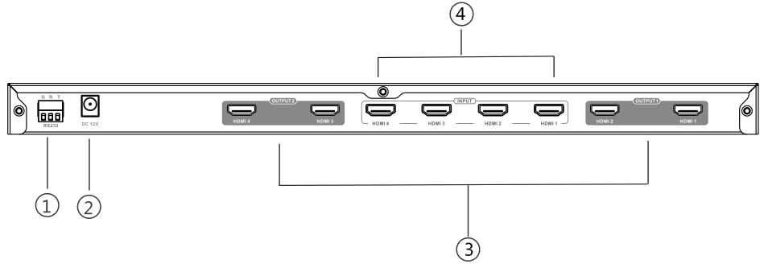
① RS232 serial port
② Power connector(DC12V)
③ HDMI output port
④ HDMI input port
Remote Controller
This remote controller is just used for inputs
or outputs switching/selection.

RS232 Serial command

1、How to use RS232 serial ports?

One Mode:(recommend)

Click the link https://www.lenkeng.net/mail/LKV414-RS232-Serial-command.zip

to download and install the software. run HDMI Matrix2.bat

Operating the program according to the PDF document named serial command.

Two Mode:(when One Mode fail or no work)

Click the link https://www.lenkeng.net/mail/LKV414-RS232-Serial-command.zip

to download and install the software. click the Document folder RS232 and copy to My Computer.

Copy MSCOM32.OCX to C:\WINDOWS\system32.and run command “regsvr32 mscomm32.ocx”.

Click HDMIMatrix2.EXE, make it running on your computer.

Operating the program according to the PDF document named serial command.

NOTE: Only use to Microsoft System
2. Serial port control command format:
The command length is 3 bytes.
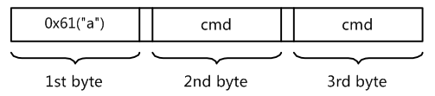
- Command list:
The command data is the same as IR key data. For example:"a59"
(0x613539) is setting the source of the output2 to the third input port.
"a41"(0x613431) is skiping the source of the outport1 to the next input port.
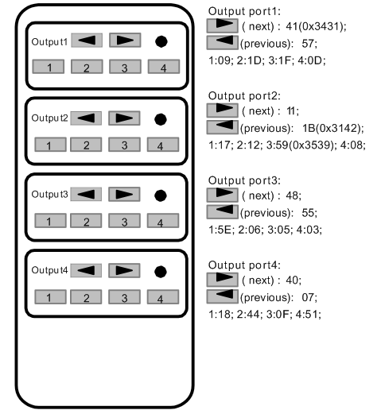
When you send a control command to the HDMI Matrix,if success,it
will return current Output
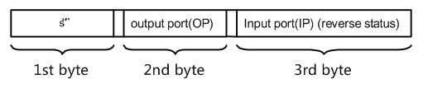
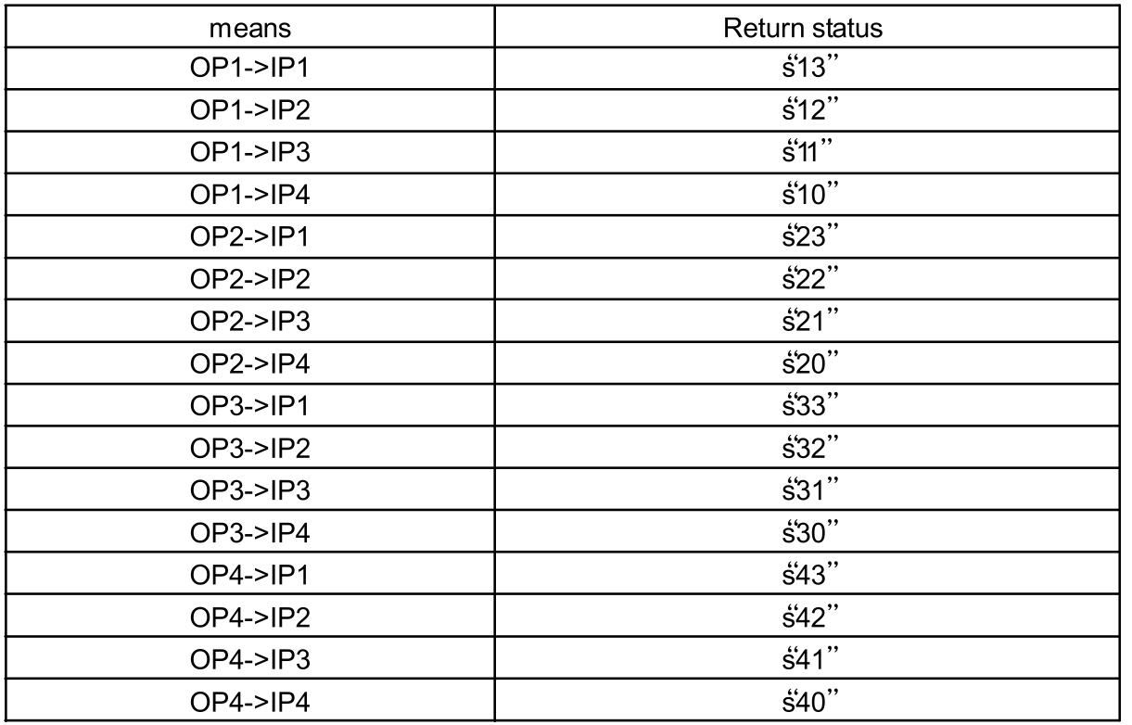
For example:if you send"a59" to HDMI Matrix-002,if:success,it will
return"s21",means OP2
- Read Status Command
The Command length is 3 bytes
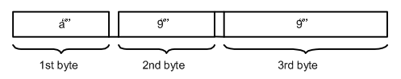
When you send the read status command to HDMl Matrix, if success,
it will return the status of the OP(bot OP1 and OP2).For example:
when you send "a99"to HDMl Matrix-002, if success , it will
return's1xs2ys3zs4a". that's means OP1 select IP(4-x), OP2 select
IP(4-y), OP3 select IP(4-z), OP4 select IP(4-a)."s12s23s33s40"means
OP1 select IP2, OP2 select IP1, OP3 select IP1 and OP4 select IP4.

Connections
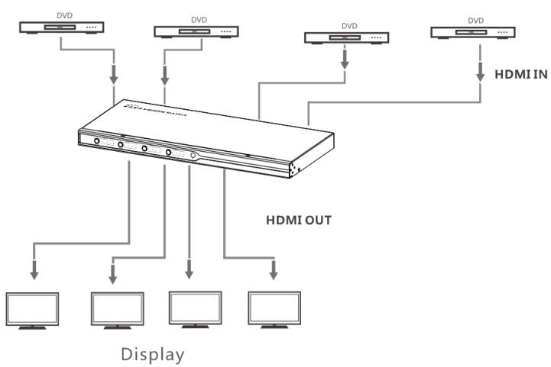
1) Connect all your HDMI source devices to this product's inputs
via HDMI cables.
2) Connect up to the HD display devices on the HDMI outputs via
HDMI cables.
3) Power on all source device, this Matrix Switch and display device,
then it works.
4) Select/switch inputs and outputs via IR remote , buttons or
RS232 command

FAQ
Q: No video/audio signal output on the displays?
A: 1) Please check and make sure the Matrix Switch is connected well
and powered.
2) Please check and make sure all HDMI cables are connected well
3) Please check and make sure the input channel of displays are
correct.
Q: Picture quality is not fluent and stable ?
A: 1) Please check and make sure all HDMI cables are connected well.
2) Try to connect the source device to display device directly, or
change to another source device for a try to see the picture quality.
3) Please use high quality HDMI1.4 standard cable when HDMI 4Kx2K
signal input.

Specification
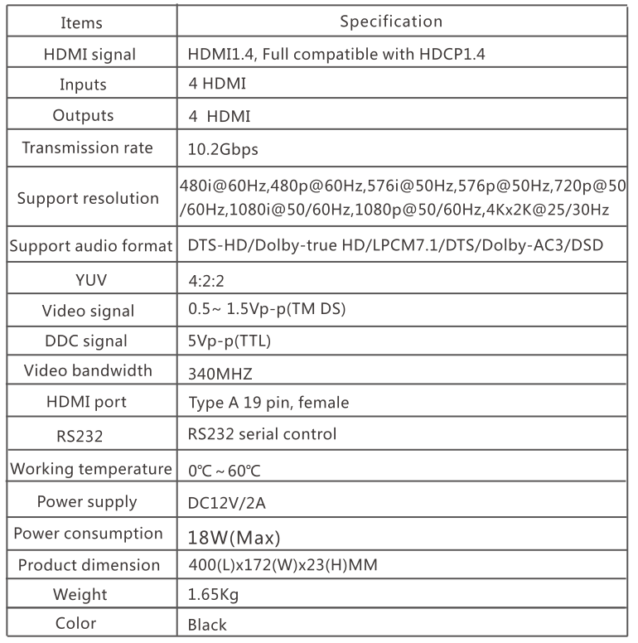

Disclaimer
The product name and brand name may be registered trademark of
related manufacturers.TM and ® may be omitted on the user manual.
The pictures on the user manual are just for reference, and there may be
some slight difference with the real products.We reserve the rights to
make changes without further notice to a product or system described
herein to improve reliability, function or design.

